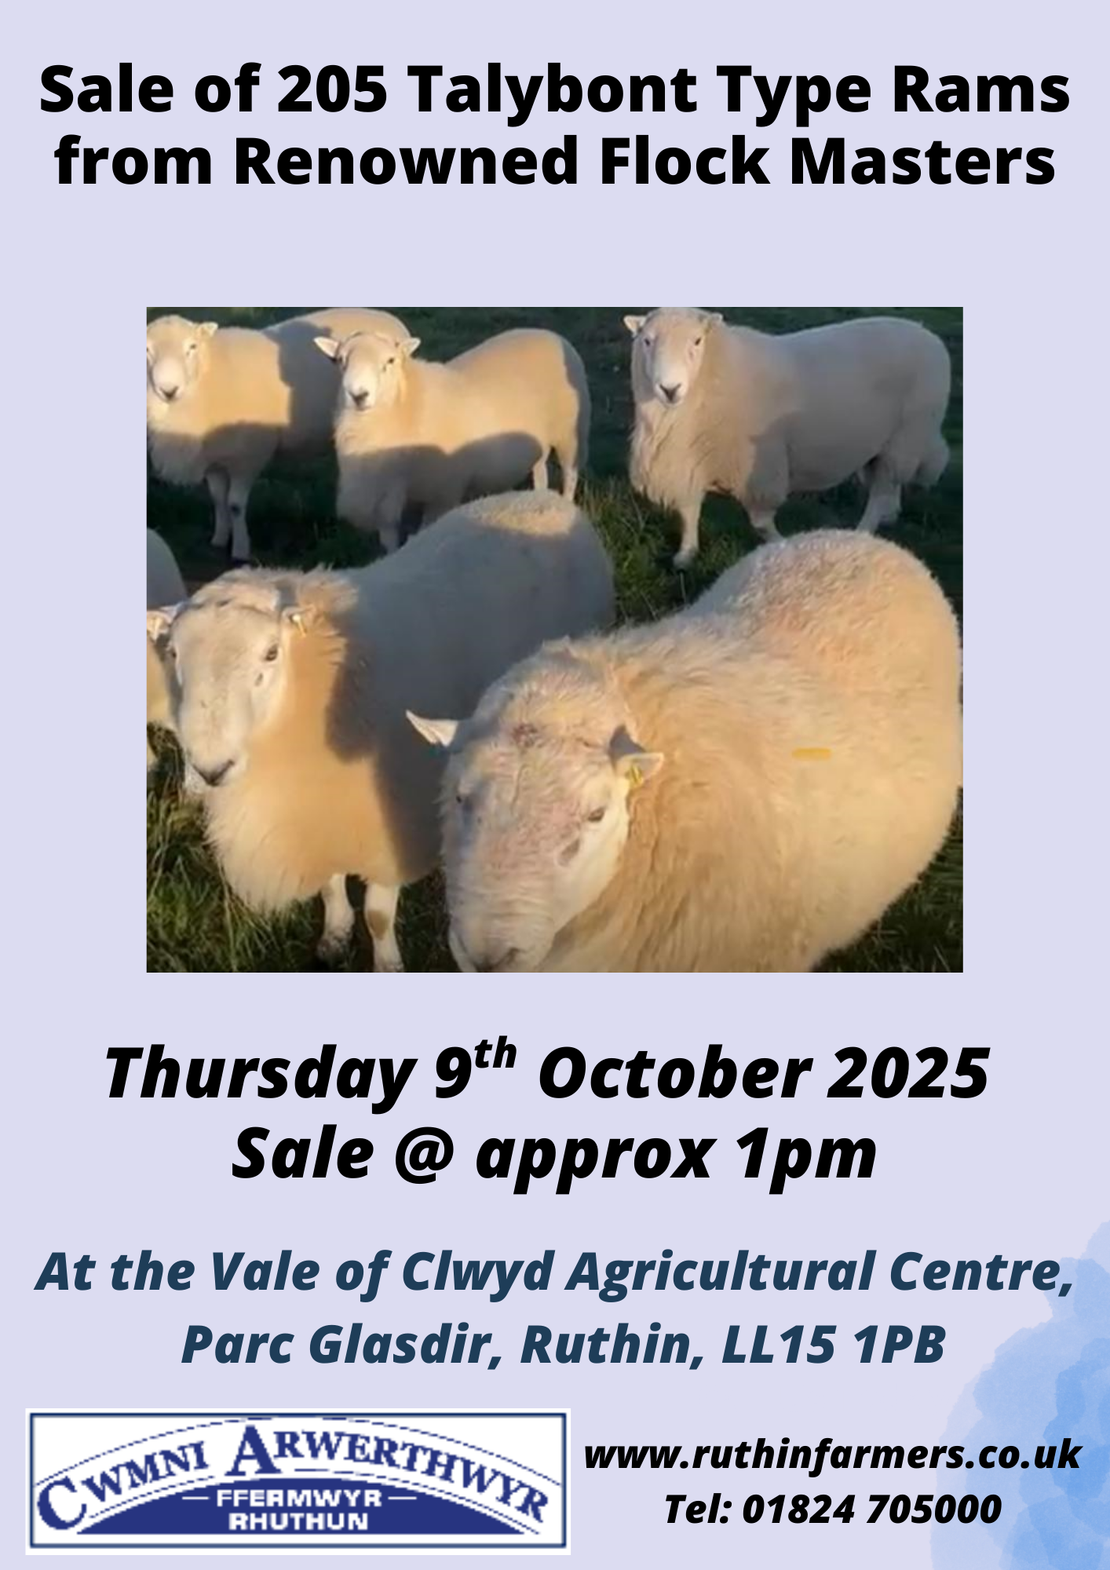
..

Lot 1001 - 1004 4 Ram lambs D I Hughes, Cefngwyrgrug

Lot 1005 - 1009 5 Yearling Rams JI & RV Parry, Esgairweddan

Lot 1010 - 1014 5 Yearling Rams M & MG Parry, Orsedd Fawr

Lot 1015 - 1018 4 Yearling Rams R Gwion Owen, Hendre Arddwyfan

Lot 1019 - 1020 2 Yearling Rams Dafydd Roberts, Tyn y Gilfach
Lot 1021 - 1022 2 4Tooth Rams

Lot 1023 - 1027 5 Improved Welsh type T & G Williams, Bodgaeaf Uchaf
Yearling Rams Heptavac P+ sysem, wormed

Lot 1028 - 1032 5 Yearling Rams Gari Jones, Fron Bella

Lot 1033 - 1037 5 Yearling Rams Arwyn Evans, Foel Cathau

Lot 1038 - 1041 4 Yearling Rams H Edwards a’i gwmni, Bwlch Mawn

Lot 1042 - 1046 5 Yearling Rams W W Owen, Towyn

Lot 1047 - 1051 5 Yearling Rams P A Smith, Bodtegir
Hep P+, dipped, fluke & worm

Lot 1052 - 1056 5 Yearling Rams H C Williams, Tain y Foel

Lot 1057 - 1061 5 Yearling Rams GM & HI Evans Plas Iolyn

Lot 1062 - 1066 5 Yearling Rams R Evans, Berth Farm

Lot 1067 - 1071 5 Llandovery White Face
Yearling Rams Elfyn Owen, Ffrith Arw

Lot 1072 - 1074 3 Yearling Rams Hughes & Co, Ystrad Fawr

Lot 1075 - 1079 5 Yearling Rams Huw Jones, Caer Weirglodd

Lot 1080 - 1084 5 Yearling Rams G W Jones, Nant Erw Haidd

Lot 1085 - 1089 5 Yearling Rams H & E Jones, Ty Mawr

Lot 1090 - 1094 5 Yearling Rams G V Jones, Hirdref Uchaf

Lot 1095 - 1099 5 Yearling Rams P A Smith, Bodtegir
Hep P+, dipped, fluke & worm

Lot 1100 - 1104 5 Yearling Rams H C Williams, Tain y Foel

Lot 1105 - 1109 5 Yearling Rams GM & HI Evans Plas Iolyn

Lot 1110 - 1113 4 Yearling Rams R Evans, Berth Farm
Lot 1114 1 3yr old Ram

Lot 1115 - 1119 5 Llandovery White Face
Yearling Rams Elfyn Owen, Ffrith Arw

Lot 1120 - 1122 3 Yearling Rams Hughes & Co, Ystrad Fawr

Lot 1123 - 1127 5 Yearling Rams Huw Jones, Caer Weirglodd

Lot 1128 - 1132 5 Yearling Rams G W Jones, Nant Erw Haidd

Lot 1133 - 1137 5 Yearling Rams H & E Jones, Ty Mawr

Lot 1138 - 1142 5 Yearling Rams G V Jones, Hirdref Uchaf

Lot 1143 - 1147 5 Yearling Rams P A Smith, Bodtegir
Hep P+, dipped, fluke & worm

Lot 1148 - 1152 5 Yearling Rams H C Williams, Tain y Foel

Lot 1153 - 1157 5 Yearling Rams GM & HI Evans Plas Iolyn

Lot 1158 - 1161 4 Yearling Rams R Evans, Berth Farm

Lot 1162 - 1163 2 Llandovery White Face
Yearling Rams Elfyn Owen, Ffrith Arw

Lot 1164 - 1168 5 Yearling Rams P A Smith, Bodtegir
Hep P+, dipped, fluke & worm

Lot 1169 - 1173 5 Yearling Rams H C Williams, Tain y Foel

Lot 1174 - 1177 4 Yearling Rams GM & HI Evans Plas Iolyn

Lot 1178 - 1182 5 Yearling Rams Gari Jones, Fron Bella

Lot 1183 - 1184 2 Aged Rams Dafydd Roberts, Tyn y Gilfach

Lot 1185 - 1187 3 4Tooth Rams R Gwion Owen, Hendre Arddwyfan

Lot 1188 - 1191 4 Ram lambs D I Hughes, Cefngwyrgrug

Lot 1192 - 1196 5 Yearling Rams JI & RV Parry, Esgairweddan

Lot 1197 - 1201 5 Yearling Rams M & MG Parry, Orsedd Fawr

Lot 1202 – 1205 4 Yearling Rams Sam Jones, Fron Goch Farm

NOTES

